PHYSIOLOGICAL EXPERIMENTATION WITH THE CRAYFISH HINDGUT: A STUDENT LABORATORY EXERCISE
Introduction
The purpose of the exercise is to monitor peristaltic activity in the crayfish hindgut with and without the addition of various compounds. It is very easy to dissect and record contractions from the crayfish hindgut. In the dissected preparation, the gut is easily exposed to exogenous substances. The alteration in peristaltic activity can be monitored visually or with a force transducer.
Alexandrowicz (1909) identified two nerve plexuses innervating the crustacean hindgut, an inner plexus and an outer plexus, which later proved to be rich sources for identifying and characterizing neurotransmitters. In the 1950’s Dr. Ernst Florey began a series of pharmacological studies on the crayfish hindgut and demonstrated that contractions are modulated by acetylcholine and its related compounds and also by epinephrine and norepinephrine (Florey, 1954). Florey, the discoverer of an inhibitory substance known as “Factor-I,” studied the effects of this substance on various preparations, including the GI system in crayfish (Florey, 1961). Factor-I was later shown to be GABA. Thus, the crayfish hindgut played an important role in the early studies of synaptic inhibition.
Although the crustacean hindgut contracts spontaneously following denervation, such contractions are typically weak and disorganized (Wales, 1982; Winlow & Laverack, 1972a). Peristaltic movement requires coordinated motor output from the central nervous system, apparently originating in the last abdominal ganglion (Winlow & Laverack, 1972a, b, c). In crayfish, the motor output is carried to the hindgut through the 7th abdominal root, which contains 75 axons whose cell bodies are localized in the last abdominal ganglion (Kondoh & Hisada, 1986). At least some of the peptides appear to be supplied to the hindgut plexus from neurons originating in the last abdominal ganglion (Dircksen et al. 2000; Mercier et al. 1991b; Siwicki & Bishop, 1986), but dopamine is supplied by neurons in more anterior ganglia (Mercier et al. 1991a). Since motor output through the 7th abdominal root is necessary for large, coordinated contractions, it is likely that some or all of the putative transmitters listed above contribute in some way to peristalsis. Their relative contributions, however, are not known. Some insight may be gained by studying their effects on circular and longitudinal muscles separately (Mercier & Lee, 2002).
It is interesting to note that the anal portion of the hindgut acts not only to expel feces but also to take up the water from the environment for osmoregulation. This region of the gut can undergo forward or reverse peristalsis depending on the animal’s needs.
Materials
crayfish
crayfish saline
dissection instruments (coarse & fine scissors, coarse & fine forceps)
Sylgard-bottomed Petri dish
steel dissecting pins
beakers (to hold chemical solutions)
parafilm (for covering & mixing solutions)

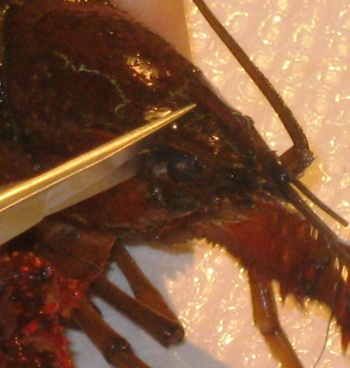
Preparation Dissection
- Crayfish (Procambarus clarkii) measuring 6-10 cm in body length should be placed on ice for 5 to 10 minutes to anesthetize the animal before dissection begins.
- Hold the anesthetized crayfish from behind the claws with one hand. Quickly, cut from the eye socket to the middle of the head on both sides, and then behead the crayfish (Note: the blood from the preparation will be sticky when it dries, so wash the tools when completed).

- Cut off the chelipeds and walking legs.
- Cut off the left and right tailfins, only leaving the middle tailfin (uropod).
- On the dorsal side of the crayfish cut ventrally on both the left and right side of the dorsal cuticle.
Figure 2: Removal of Dorsal Cuticle
- Cut transversely on the dorsal side of the cuticle, making sure that the cut is shallow to prevent damage to the G.I. Then remove the lower section of the dorsal abdominal cuticle.
- Place the dissected crayfish into a Sylgard-lined dish.
- Pin the crayfish to the dish at the tip of the tailfin. One may use more pins on either side of the G.I. as necessary to hold the body down.
- Fill the dish with crayfish saline covering the G.I. Make sure to continually douse the G.I. with saline using a pipette. Saline is a modified Van Harreveld’s solution (1936), which is made with 205 mM NaCl; 5.3 mM KCl; 13.5 mM CaCl₂ 2H₂O; 2.45 mM MgCl₂ 6H₂O; 5 mM HEPES and adjusted to pH 7.4. The dissected crayfish should appear as shown in Figure 3.
Figure 3: Dissected crayfish with GI intact.
Methods:
A. Contractions in the animal
1. Have solutions of the compound to be tested ready and at the same temperature as the bathing saline. On might use individual solutions of serotonin (100 nM, 1microM), glutamate (1microM) and dopamine (1microM) made in crayfish saline as starting substances to be tested
2. Allow the dissected crayfish to sit in the crayfish solution for about ten minutes to allow it to adjust to the shock of dissection and saline exposure. The slow peristalsis contractions from the hindgut should start to occur.
3. Once the contractions begin, record the number of contractions that occur in thirty seconds (note the type of contractions that occur: i.e. peristalsis type, or spastic and the direction of any peristaltic waves).
Table 1: Contractions in Crayfish Saline
Number of Contractions | Type of Contractions
4. Using a pipette, remove the saline within the cavity of the crayfish’s exposed abdomen, and apply saline containing the substance to be examined directly onto the hindgut.
5. Immediately after adding the solution, record the number of contractions that occur after thirty seconds and note the type of contractions that occur (i.e. peristaltic, or spastic).
Table 2: Contractions with exposure to compounds
Compound tested | Concentration | Number of Contractions | Type of Contractions
6. Immediately after recording the response to the test substance, rinse the G.I. several times with normal crayfish saline. Let the preparation stand for 5 minutes, while rinsing about every 30 seconds with crayfish saline.
7. Using a pipette, place some saline containing the next compound to be examined or a varied concentration of the last substance tested directly onto the hindgut. It is best to start with a lower concentration and work one’s way to higher concentrations.
8. Immediately after adding each new substance or each new concentration, record the number of contractions that occur after thirty seconds and note the type of contractions.

B. Recording forces of contraction in excised preparations
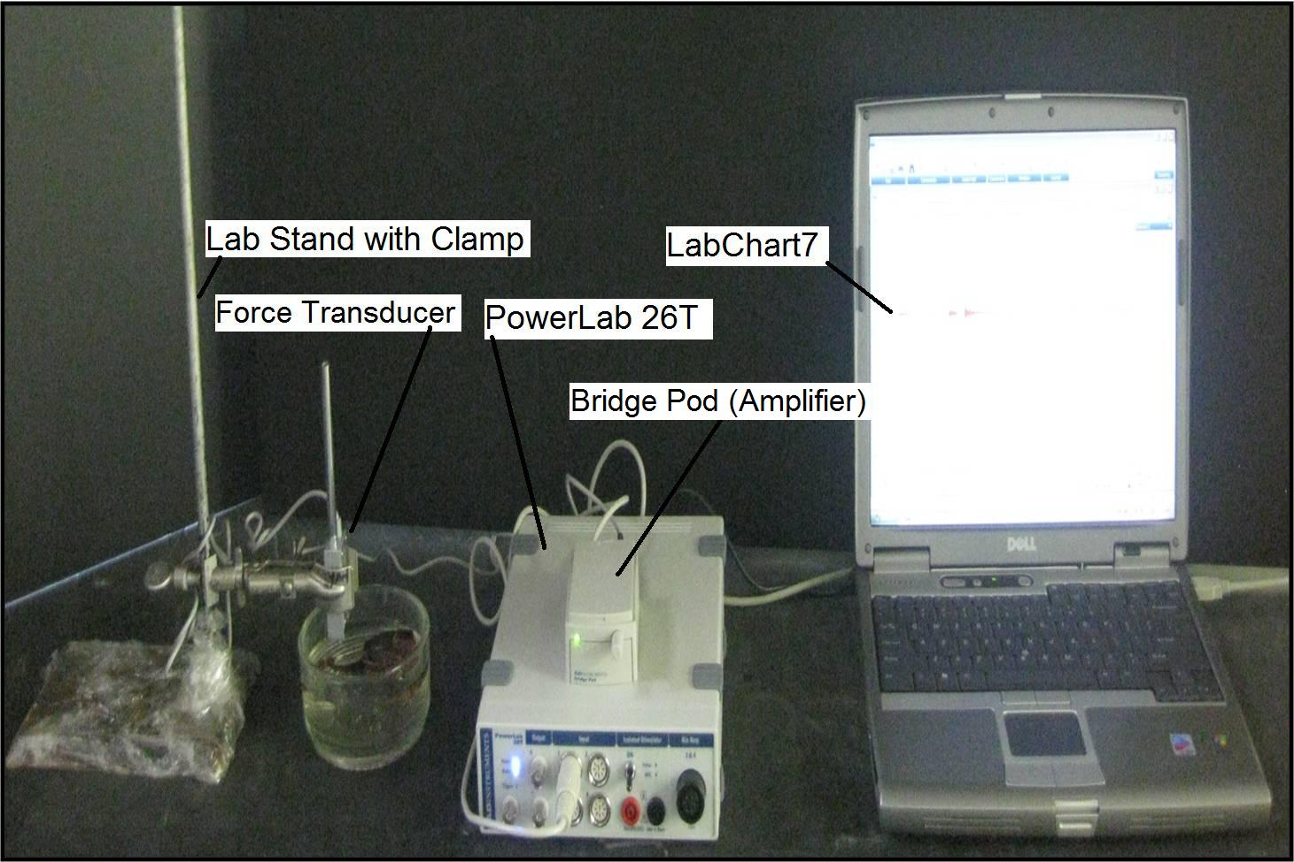
Figure 4: Setup
1. Attach the transducer to the bridge pod.
2. Attach the bridge pod to the PowerLab 26T.
3. Attach the PowerLab 26T to the USB port on the computer.
4. Open LabChart7, by clicking on the labchart7 icon on the desktop.
- The LabChart Welcome Center box will pop open. Close it.
- Click on Setup
- Click on channel settings. Change the number of channels to 1 (bottom left of
box) push OK.
-At the top left of the chart set the cycles per second to about 2k. Set the volts (y-
axis) to about 500 or 200 mV.
-Click on Channel 1 on the right of the chart. Click on Input Amplifier. Ensure
that the settings: single-ended, ac coupled, and invert (inverts the signal
if needed), and anti-alias , are checked.
- To begin recording press start.
5. Pick up the preparation and cut the GI tract at the juncture between the thorax and the abdomen. Then carefully cut around the telson part of the tail. Remove the GI tract from the dissected crayfish and place it into the Sylgard dish. There is a blood vessel that runs along the dorsal aspect of the GI tract. Carefully pull this away from the GI tract. Pour fresh crayfish saline onto the preparation.
6. Place the force transducer in the clamp near the dissected crayfish.
7. Hook the force transducer in the crayfish G.I. as shown in Figure 5.
Figure 5: Isolated hindgut of the crayfish in saline attached to the hook of the force transducer
8. Wait until the G.I. starts to contract, and push start on the LabChart7.
9. Let the program run for about 20 seconds. Push “stop,” and add a comment labeled,
“Saline only”. Fill out the Table 4 .
Table 4: Contractions with compound of interest
Number of Contractions | Amplitude of Contractions (mV)
10. Add the test compounds of interest, and immediately push “start” on the LabChart7.
11. Let the program run for about 20 seconds. Push “stop” and add a comment directly on the chart file as to what substance was added and its concentration. Fill out the table below.
Table 5: Contractions with _________ compound

Number of Contractions | Amplitude of Contractions (mV)
12. Rinse off the preparation with crayfish saline using a pipette.
13. Add other substances or various concentrations in a similar manner. Immediately push “start” on the LabChart7.
14. Let the program run for about 20 seconds. Push “stop,” and add a comment and label directly on the chart file indicating the compound used and the concentration.
Data Analysis
1. From Part A of the experiment, graph the number of contractions from each solution (saline, serotonin, glutamate) vs. time. Explain any trends.
2. From Part B of the experiment, graph the number of contractions from each solution (saline, serotonin, glutamate) vs. the amplitude of the contractions in mV. Explain any trends.
Measuring the rate and force of contractions
To index the rates of contractions on can measure the time from the beginning on one deflection to the beginning of the next or count the total deflections over a minute or two. The values can then be put in terms of contractions per min or per second depending on how rapid they are occurring.
To index the force of contractions a relative measure could be used to compare different conditions. On the saved file one can use the marker “M” and move to the baseline. Then use the cursor and move to the peak of the deflection and take note of the value listed on the top right of the screen as a delta value (the difference from M to the peak). Note the cursor needs to be kept stationary for the measure of the change. Then move the M to the next waveform of interest and repeat the measure.
Discussion:
The details provided in the associated movie and text describe the key steps needed to record the activity in the hindgut of the crayfish in situ as well as in vitro. One goal of our report is to increase the awareness to the potential of this preparation in student-run investigative laboratories that teach fundamental concepts in physiology and pharmacology.
These preparations can be used to investigate a number of experimental questions that will lead to a better understanding of the physiological functions of the hindgut. The mechanisms underlying regulation of peristaltic waves and their reversal are still not known. The mechanisms for higher control of the entire GI tract are also not fully understood. The question of how higher centers integrate their activity with the autonomic output that directly controls the GI system remains an open area of investigation (Shuranova et al., 2006). In addition, the osmoregulatory capabilities of the crustacean hindgut and the functions of osmoregulation during molting and environmental stress have not been fully elucidated. There are still many questions awaiting answers in this preparation.
References:
Alexandrowicz, J. S. Zur Kenntnis des sympathischen Nervensystems der Crustaceae. Jena Z. Naturw. 45, 395-444 (1909).
Bungart, D., Dircksen, H. & Keller, R. Quantitative determination and distribution of the myotropic neuropeptide orcokinin in the nervous system of astacidean crustaceans. Peptides 15, 393-400 (1994).
Dircksen, H., Burdzik, S., Sauter, A. & Keller, R. Two orcokinins and the novel octapeptide orcomyotropin in the hindgut of the crayfish Orconectes limosus: identified myostimulatory neuropeptides originating totether in neurons of the terminal abdominal ganglion. J. Exp. Biol. 203, 2807-2818 (2000).
Elekes, K., Florey, E., Cahil, M.A., Hoeger, U. & Geffard, M. Morphology, synaptic connections and neurotransmitters of the efferent neurons of the crayfish hindgut. In: Salanki J, Rosza K (eds) Neurobiology of Invertebrates, Vol. 36, Akademiai Kiado, Budapest, pp 129-146 (1988).
Elofsson, R., Kauri, T., Nielsen, S.O. & Stroemberg, J.O. Catecholamine-containing nerve fibres in the hindgut of the crayfish Astacus astacus L. Experentia 24, 1159-1160 (1968).
Florey, E. Uber die wirkung von acetylcholin, adrenalin, nor-adrenalin, faktor I und anderen substanzen auf den isolierten enddarm des flusskrebses Cambarus clarkii Girard. Z. Vergl. Physiol. 36, 1-8 (1954).
Florey, E. A new test preparation for bio-assay of Factor I and gamma-aminobutyric acid. J. Physiol. 156, 1-7 (1961).
Jones, H.C. The action of L-glutamic acid and of structurally related compounds on the hind gut of the crayfish. J. Physiol. (London) 164, 295-300 (1962).
Knotz, S. & Mercier, A.J. cAMP mediates dopamine-evoked hindgut contractions in the crayfish, Procambarus clarkii. Comp. Biochem. Physiol.111A, 59-64 (1995).
Kondoh, Y. & Hisada, M. Neuroanatomy of the terminal (sixth abdominal) ganglion of the crayfish, Procambarus clarkii (Girard). Cell. Tiss. Res. 243, 273-288 (1986).
Mercier, A.J., Lange, A.B., TeBrugge, V. & Orchard, I. Evidence for proctolin-like and FMRFamide-like neuropeptides associated with the hindgut of the crayfish, Procambarus clarkii Can. J. Zool. 75, 1208-1225 (1997).
Mercier, A.J. & Lee, J. Differential effects of neuropeptides on circular and longitudinal muscles of the crayfish hindgut. Peptides 23, 1751-1757 (2002)..
Mercier, A.J., Orchard, I. & Schmoeckel, A. Catecholaminergic neurons supplying the hindgut of the crayfish, Procambarus clarkii. Can. J. Zool. 69, 2778-2785 (1991a).
Mercier, A.J., Orchard, I. & TeBrugge, V. FMRFamide-like immunoreactivity in the crayfish nervous system. J. exp. Biol. 156, 519-538 (1991b).
Mercier, A.J., Orchard, I., TeBrugge, V & Skerrett, M. Isolation of two FMRFamide-related peptides from crayfish pericardial organs. Peptides 14, 137-143 (1993).
Musolf, B.E. Serotonergic modulation of the crayfish hindgut: Effects on hindgut contractility and regulation of serotonin on hindgut. Dissertation (2007). (Downloaded from an open access source at Georgia State University; http://etd.gsu.edu/theses/available/etd-11272007-175638/ )
Musolf, B.E., Spitzer, N., Antonsen, B.L. & Edwards, D.H. Serotonergic modulation of crayfish hindgut. Biol Bull. 217(1), 50-64 (2009).
Shuranova, Z.P., Burmistrov, Y.M., & Cooper, R.L. A hundred years ago and now: A short essay on the study of the crustacean hindgut. (Vor hundert Jahren und nun: Eine kurze Geschichte von die Forschung des Hinterdarmes der Crustaceen). Crustaceana 76, 755-670 (2003).
Shuranova, Z.P., Burmistrov, Y.M., Strawn, J.R. & Cooper, R.L. Evidence for an Autonomic Nervous System in Decapod Crustaceans. International Journal of Zoological Research 2(3), 242-283 (2006).
Siwicki, K.K. & Bishop, C.A. Mapping of proctolinlike immunoreactivity in the nervsou systems of lobster and crayfish. J. comp. Neurol. 243, 435-453 (1986).
Stemmler, E.A., Cashman, C.R., Messinger, D.I., Gardner, N.P., Dickinson, P.S. & Christie, A.D. High-mass-resolution direct-tissue MALDI-FTMS reveals broad conservation of three neuropeptides (APSGFLGMRamide, GYRKPPFNGSIFamide and pQDLDHVFLRFamide) across members of seven decapod crustaean infraorders. Peptides 28, 2104-2115 (2007).
Wales, W. Control of mouthparts and gut. In: The Biology of Crustacea, Vol. 4; D.C. Sandeman and H.L. Atwood, eds.; Academic Press Inc., London; pp. 165-191 (1982).
Webster, S.G., Dircksen, H. & Chung, J.S. Endocrine cells in the gut of the shore crab Carcinus maenas immunoreactive to crustacean hyperglycaemic hormone and its precursor-related peptide. J. Exp. Biol. 300, 193-205 (2000).
Winlow, W. & Laverack, M.S. The control of hindgut motility in the lobster Homarus gammarus (L.). 1. Analysis of hindgut movements and receptor activity. Mar. Behav. Physiol. 1, 1-28 (1972a).
Winlow, W. & Laverack, M.S. The control of hindgut motility in the lobster Homarus gammarus (L.). 2. Motor output. Mar. Behav. Physiol. 1, 29-47 (1972b)
Winlow, W. & Laverack, M.S. The control of hindgut motility in the lobster Homarus gammarus (L.). 3. Structure of the sixth abdominal ganglion (6 A.G.) and associated ablation and microelectrode studies. Mar. Behav. Physiol. 1, 93-121 (1972c).
Wrong, A.D., Sammahin, M., Richardson, R. & Mercier, A.J. Pharmacological properties of glutamate receptors associated with the crayfish hindgut. J. Comp. Physiol. 189, 371-378 (2003).

